**Title:** *Repeat short-interval fires put carbon storage at risk in Interior Alaska**via cumulative combustion of soil carbon*

Authors: Katherine Hayes1, Melissa Lucash2, Kristin Olson3, Brian Buma1, 4

1Department of Integrative Biology, University of Colorado Denver

2Department of Geography, University of Oregon

3Department of Biology and Wildlife, University of Alaska Fairbanks

4Environmental Defense Fund, Boulder, Colorado

*Corresponding author*: hayesk@caryinstitute.org

Abstract (269/300)

Fire regimes alter the distribution, accumulation, and stability of carbon stocks across multiple spatial and temporal scales, particularly in boreal ecosystems, which are globally important storehouses of terrestrial carbon stocks. In Interior Alaska, increasing temperatures and snow-free times have resulted in a greater frequency of short-interval fires (fires occurring within 50 years or less of preceding fires), which depart from historic fire-interval norms, where fires were historically infrequent and severe, occurring every 150-300 years. Increasing fire frequency causes shifts in forest structure and composition that affect carbon storage; however, the extent, strength, and mechanisms of these effects remain unclear. Fast-growing broadleaf species may lead to greater aboveground biomass in reburned stands; however, the cumulative severity of multiple fires may burn into carbon-rich soil organic layers. Here, we quantified aboveground and soil carbon in boreal black spruce (*Picea mariana*) stands that burned once, twice, or three times in the last 70 years within short intervals (>50 years). We quantified the effects of cumulative severity, stand structure, and composition on both aboveground and soil carbon in upland and lowland stands. Total carbon in reburned stands declined with additional fires, even with increases in tree density of faster-growing deciduous trees. Cumulative severity had the largest effect on aboveground biomass and soil carbon stocks in both sites, but particularly in upland stands, indicating that the effects of continued reburning on carbon storage may differ across topographic position. This study expands our understanding of future carbon dynamics in boreal forests, particularly in the context of emerging reburning, and contributes to a larger body of knowledge on the effects of continued disturbances on carbon storage.

**Keywords:** Carbon, boreal, short-interval fires, reburning, fire

# Introduction

Boreal forests are globally important carbon storehouses; as much as 30% of the world’s terrestrial carbon stocks are stored within the forest floor and soil (IPCC 2021). In interior Alaska, fire drives the distribution, accumulation, and stability of C across spatial and temporal scales (Kasischke and Stocks 2012). However, changing climate and wildfire regimes may threaten boreal carbon stocks at regional scales (Walker et al. 2019; Dieleman et al. 2020) with the potential to exacerbate global climate change.

Soil carbon is the dominant form of carbon in boreal forests: limited aboveground productivity and cold and/or anaerobic soil conditions promote permafrost and the accumulation of “legacy” carbon (carbon that persists across fire events, Walker et al. 2019). Fires have been a feature of the landscape for 10,000 years, with return intervals within 100-300 years (Higuera et al. 2008). Fires consume a fraction of soil carbon, even under historical regimes. Following fire, soil carbon may reaccumulate via several mechanisms, including increased input via litter from regenerating biomass, production of pyrogenic carbon, and decreased decomposition rates from physical shifts in porosity, pH, and stability driven by combustion (Pellegrini et al. 2022). Thus, after a single fire event, soil carbon recovers relatively quickly in black spruce stands, reaccumulating 20-40 grams per year (Harden et al. 2012; Kane and Vogel 2009; O’Neill et al. 2006). Consequently, soil carbon inputs from litter or pyrogenic carbon balance soil carbon losses from combustion within 7 to 15 years after fire (O’Neill et al. 2006; Shabaga et al. 2022). However, fires that reburn previous fire perimeters within short intervals (repeat fires or reburns) can burn more deeply into organic soils, releasing not only larger amounts of carbon but also combusting legacy carbon (Walker et al. 2019) and increasing the rate of permafrost thaw due to thin (or eliminated) insulating organic layers.

Although soil C dominates the stock response to fire, aboveground carbon is more dynamic and strongly mediates *how* changes in the fire regime will alter carbon stocks in the future, both above- and belowground. Black spruce forests cover nearly 45% of all forested area in Alaska (Calef et al. 2005; van Cleve et al. 1983), and store the greatest amount of carbon relative to other forest types in the region (Johnson and Kern 2002). Thick soil organic layers associated with black spruce forests prevent seed germination of broadleaf species, whose smaller seeds cannot survive in moss layers as long as larger black spruce seeds (Johnstone and Chapin 2006), maintaining “ecological inertia” at the landscape scale (Harden et al. 2006). In addition, coniferous forests regenerate strongly after a fire via serotinous cones, enforcing strong legacy seedbank conditions (Johnstone et al. 2010). However, a single reburn (a second fire that burns shortly after the first) can produce mixed regeneration stands, as slow-growing, dispersal-limited spruce are killed prior to maturity, particularly in the initial decades after fire. Continued reburning (multiple short-interval fires) can convert dense black spruce stands into open broadleaf stands (Hayes and Buma 2021).

Fast-growing deciduous species produce greater overall aboveground carbon than black spruce 20-60 years after fire events (Alexander et al. 2012), outweighing losses in carbon from soil consumption (Mack et al. 2021). Over a third of Alaskan black spruce stands are considered susceptible to shifting to deciduous dominance via reburn-conversion (Kurkowski et al. 2008).

Given the above, resolving questions about fire frequency and their impact on those key drivers – soil, forest density, and forest composition – are key to resolving whether aboveground carbon pool increases will offset losses in belowground carbon pools under novel reburning conditions. This is critical for understanding the future of carbon cycling across the North American boreal.

This study quantified aboveground and soil carbon in reburned stands and investigated the role of forest composition, forest structure, and cumulative fire severity in altering above- and belowground carbon pools. We asked the following questions: 1) What is the impact of continued reburning on carbon stocks (aboveground live, soil, dead, and total) in boreal forests? and 2) How do site-level differences in tree density, forest composition and soil consumption correlate with total carbon storage in reburned uplands and lowlands?

# Methods



**Figure 1. Map of Study Sites. Upper map displays location of upland study plots, lower map shows lowland study plots. Note the difference in scale indicated by the scale bar.**

## Study design

The study was conducted at two locations in Interior Alaska that have experienced 0-3 fires at intervals of < 30 years (the most recent burn in all plots was 2004 or 2005). Sites were originally dominated by mature black spruce stands, confirmed via aerial photography and remote sensing (Hayes and Buma 2021), and contain a mosaic of overlapping fire perimeters from 1953 to 2005, allowing for opportunistic, spatially constrained sampling of different fire frequencies in areas with the same initial composition. We established 50 400 m2 plots in summer field seasons of 2018 and 2019, a minimum of 90 m apart (Fig. 1). Reburned plots (n = 42) were established a minimum of 100 m from burn perimeters, outside the dispersal distance of black spruce (~ 50 m; LeBarron 1939). All burned stands experienced complete aboveground mortality during each fire. We also established eight unburned reference plots within bordering unburned black spruce remnant forests.

We cored snags of each species represented in each plot to estimate the stand age of mature plots and to confirm the fire history in reburned plots, ensuring that no trees survived prior to fires. Cores were mounted, sanded, and then imaged using ImageJ to visualize fine rings (Schneider et al. 2012).

### Estimating Aboveground Carbon

We estimated aboveground carbon in the field by measuring tree and shrub diameters above diameter at breast height (DBH, 1.37 m). At sites where very high densities precluded sampling the full 400-m2, we sampled across a randomly selected 100-m2 subplot and scaled up. We used regionally developed, species-specific allometric equations (Bond-Lamberty et al. 2002, Byrd 2013) to estimate total aboveground carbon within live and dead trees (see specifics in Appendix 1: Table S1). We were unable to locate local allometric equations for *Alnus viridis crispa* based on DBH, and relied on regional equations for *Alnus viridis sinuata* instead (Binkley et al. 1984). We assumed biomass was 50% carbon.

To account for carbon stored in dead or downed trees and debris, we measured downed woody debris (DWD, dead wood lying or standing at <450 angle) using two 28-m transects crossing the center of each plot and converted DWD field data into estimates of mass per area (grams per meter) following Brown (1974).

To estimate herbaceous and shrub understory plant biomass, we harvested all material in 10 randomly selected 1 m2 subplots in each plot and dried samples at 50 °C. We scaled the resulting dry weight to estimate understory biomass.

### Estimating Soil Carbon

We took soil cores at the corners and the center of each plot (n = 5 per plot) using a 15-cm depth volumetric sampler, sampling the entire organic layer and then 15 centimeters of the mineral. Mineral soil samples were sieved into two size classes (>2 mm and <2 mm) and homogenized in plastic bags. We ground soils using a roller mill before combusting in a Costech 8020 Elemental Analyzer to estimate the carbon content of each sample. We calculated the total carbon contained within the organic and mineral soil horizons as the product of each horizon’s depth, bulk density, and carbon percentage.

### Data Analysis

To quantify the impact of reburning on carbon and to test for the interactive role of site, we directly compared major pools (aboveground, soil, DWD, and overall total carbon) across fire histories. To explore whether the direct and indirect effects of continued reburning (shifts in forest structure, composition, and soil organic layer) were good predictors of carbon storage in biomass and soil carbon, we used two hierarchical log-normally distributed multivariate Bayesian regression models to compare the effect sizes of site-level forest structure, composition, and cumulative severity on (1) live aboveground biomass and (2) soil carbon. The model structure was the same for both response variables, with a slight difference in modeled sources of measurement error (see below):

$${log⁡(μ}_{ij})= α_{j}+{β1(Density)*x}_{ij}+{β2\left(Deciduous BA\right)*x}_{ij}+{β3\left(SOL\right)*x}_{ij}+ {}_{i}$$

where $μ_{ij}$ represents the mean carbon in plot i within a given site, $α_{j}$ represents the intercept, $β$ represents the slope coefficients of each predictor variable and ${}_{i}$ represents a normally distributed error term. We used the density of trees (trees per meter2) to represent forest structure, given the importance of tree density as a mechanism in Mack et al. 2021. In addition, the short and consistent time since the last burn across all sites resulted in minimal variation in height or other similar metrics of structure. To represent the shift in species composition from conifers to deciduous trees, we used the sum of the basal area of the deciduous species (basal area per m2). We selected soil organic layer depth (averaged across plots, in cm) to represent cumulative burn severity, given the role of soil consumption as a common proxy for fire severity in boreal forests (Harden et al. 2006). To compare effect sizes directly, we scaled each coefficient to a z-score between 0 and 1.

For both models, we used a Bayesian Markov Monte Carlo (MCMC) approach (Waller et al. 2003; Hooten and Hobbs 2015) to generate posterior values of coefficients. We ran 2,500 iterations across three chains and used trace plots to confirm that the Monte Carlo chains reached stationarity (Appendix: Figure S2). We intentionally selected vague priors (normally distributed, mean = 0, standard deviation = 1) to reflect the inherent lack of knowledge about the parameters, while still setting reasonable expectations.

Ecologists disagree whether measurement error (Holdaway et al. 2014) or allometric error (Chen et al. 2015) contribute to greater uncertainty in estimates of stand-level aboveground carbon. To minimize uncertainty from both sources, we relied on locally-estimated species-specific allometric equations where available (Vorster et al. 2020) and incorporated uncertainty associated with allometric equations explicitly within the model by adding a measurement error term. We incorporated uncertainty into soil carbon estimates by calculating the total uncertainty in each plot by calculating the standard deviation of the estimated Mg of carbon across cores (by plot) and summing across a plot (Fourqurean et al. 2015). The total uncertainty per plot was included as the error term variable in the soil carbon models. All models were built using the “r2Jags” package (Su and Yajima 2012, version 1) and all analysis, model fit, and selection were performed in R version 4.1.2 (R Core team 2021, *code available online*). Additional information on the modeling approach and Bayesian inference used to estimate coefficient effect size including the specification of prior distributions and specifics on the MCMC sampler are provided in the appendix (S2).

# Results

*R1. How do carbon pools (overstory live and dead biomass, understory biomass, litter biomass and soil carbon) shift with continued reburning?*

### Total Carbon

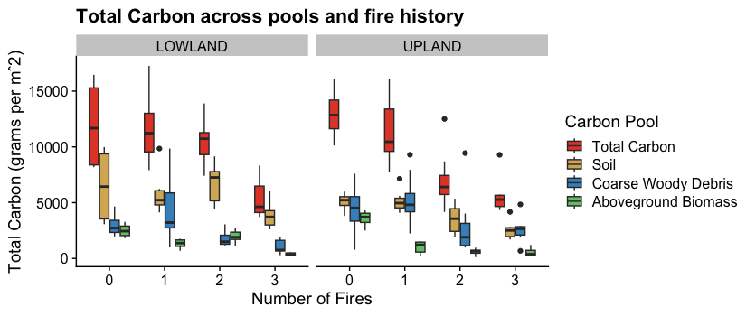

**Figure 2. Total carbon across reburn history and within carbon pools. Green represents the combined pool of carbon within live overstory and understory biomass.**

Total carbon declines as historical fire frequency increased (Fig. 2) despite the similar age of all burned plots (13-16 years since last fire); all were less than the reference stands (86-106 years since last fire; Appendix Table S2). While the lowland and upland sites contained similar amounts of total carbon in sampled pools prior to burning (lowlands average 11,999 g/m2, SD 4,299; uplands average 12,975 g/m2, SD 2,075), that total carbon was distributed differently.

### Aboveground Biomass

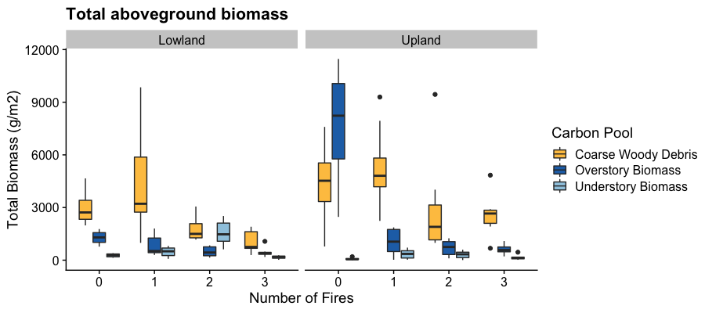

**Figure 3. Aboveground Biomass across reburn history and across pools. Blue represents pooled total aboveground biomass, dark green represents overstory biomass.**

Overstory biomass was the largest pool of aboveground carbon, regardless of reburning (Fig 3). Upland mature plots contained greater aboveground biomass prior to burning, due to both greater overstory and coarse woody debris biomass (Fig. 2). Coarse woody debris pools were greater in lowlands after one fire (from an average of 19% of total carbon to 45%) but were lower after two fires (decreasing on average 27%). Higher coarse woody debris in some upland thrice-burned plots lead to greater aboveground biomass overall in the three fire sites compared to two. Across both sites, understory biomass was the smallest carbon pool and did not appear to shift with reburning (understory biomass was an average of .09% of total carbon in unburned plots and averaged 0.46% in thrice-burned plots).

### Soil Carbon

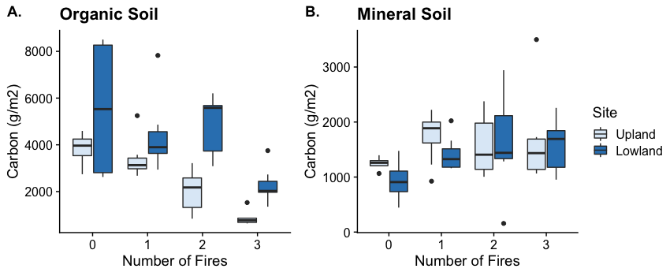

**Figure 4. Carbon abundance of mineral (A) and organic (B) soil layers across reburn history and between sites.**

Generally, soil organic layers contain more carbon than mineral soil. Carbon in mature plots in both locations was primarily stored as soil carbon (soil carbon was 39% of total carbon on average in uplands, 54% in lowlands). Trends in mineral and organic soil carbon pool size differed between lowland and upland sites (Fig. 4). Organic layer soil carbon was lower in reburned plots in both locations, but the pace of the decline occurred more rapidly in upland stands than lowlands (Fig. 4A). Estimates of soil organic layer carbon were higher in lowlands after two fires to levels similar to mature plots (average 5,546 g/m2 in twice-burned plots vs 4,880 g/m2 in unburned plots). In three fire plots, organic soil layer was consumed altogether in some plots (soil organic layers in uplands contained twice less carbon on average than corresponding mineral soils – 874 g/m2 in organicvs 1,707 g/m2 in mineral).

*R2. What are the effects of species composition, regeneration density, and cumulative severity on the abundance of aboveground and soil carbon in reburned stands?*

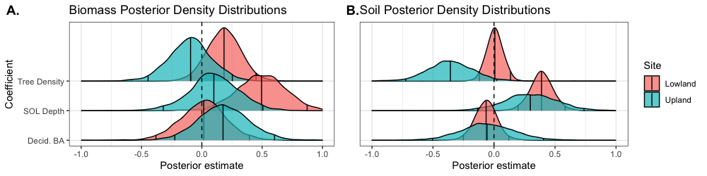

**Figure 5. Posterior density distributions for site-level variable coefficients within upland and lowland field sites. Center line indicates median, ridge lines mark the edges of a 95% interval. Coefficients are z-scores, scaled to values between 0 and 1 – thus posterior estimates occur within the same range. (A) Posterior density distribution for aboveground live biomass model. (B) Posterior density distribution for soil carbon model.**

The effects of tree density, soil organic layer depth and deciduous basal area on carbon followed similar trends across aboveground and soil pools but differed between sites (Fig. 5). Soil organic layer depth displayed the strongest positive effect size in both sites and both pools, but particularly in lowland plots. Tree density had negative effects on aboveground biomass and soil carbon in uplands, but no apparent effect on lowland soil carbon (median centered around 0) and a slight positive effect on lowland aboveground biomass. Deciduous basal area was not a strong predictor of either pool of lowland carbon; its strongest effect is on upland biomass, which increases as deciduous basal area increases.

# Discussion

We found that both aboveground and soil carbon declined with reburning in upland and lowland stands. Tree density and deciduous basal area in reburned stands did not appear to meaningfully shape variability in carbon storage, either aboveground or in soil. Rather, soil organic layer depth, a proxy for cumulative burn severity, had the strongest positive effect on total carbon, particularly in lowlands. The impact of soil loss did appear to outweigh the increase in deciduous species despite their faster growth over the observed timescales. Together, these results suggest the importance of increased fire frequency and their cumulative severity, especially of multiple fires and their potential to drive ecosystem carbon storage past documented norms.

Our mature upland stands had greater aboveground biomass than regional averages and our lowlands had lower (average aboveground biomass in 60 year-old black spruce stands is 27.7 Mg per hectare, Yarie and Billings 2002). This is in line with expectations: lowlands are generally less productive than uplands (Jafarov et al. 2013).

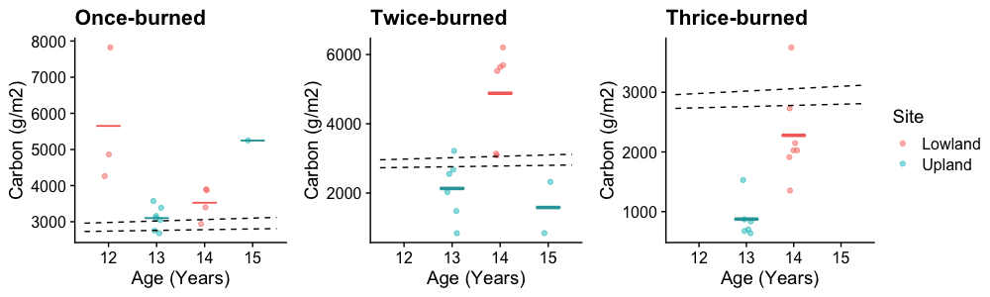

**Figure 6. Observed vs predicted soil organic layer carbon across reburns. Colored horizontal averages represent averages of sites according to age in years. Dotted lines represent the range of predicted soil carbon accumulation after fire as predicted by Harden et al. 2012 and others.**

Historically in the boreal, soil organic layer carbon recovers relatively quickly after fire events, accumulating roughly 20-40 grams of carbon per m2 per year (Harden et al. 2012; Kane and Vogel 2009; O’Neill et al. 2006). Our estimates of soil organic layer carbon in reburned stands roughly correspond to predicted carbon accumulation rates initially (once burned Fig. 6). However, our estimates of soil organic carbon in once-burned plots and unburned reference plots were higher than predictions, so our sites may have been relatively productive stands prior to reburning. Upland average soil organic carbon is lower than predictions after two fires (Fig. 6B). Furthermore, when we move into burn frequencies that have not been observed before (our three-fire sequence), our observations of soil organic layer carbon depart from expectations after three fires (Fig. 6C). The difference between upland and lowland may be because of topographic differences - lowlands have poor drainage and thus greater soil moisture - greater amounts of organic layer are consumed if the layer is dryer (Kasischke and Turetsky 2006). Carbon in soil organic layers in upland plots decline past documented ranges of reburned carbon, via potentially cumulative effects of burning. While we sampled only the top 15 centimeters of mineral soil, reburning may make even deeper soil organic carbon pools available to mobilize: Shabaga et al. (2022) found that reburning increased active layer depth, leading to higher respiration likely from decomposition of previously unavailable soil organic carbon.

Not only are the losses in carbon crucial, the implied loss of soil organic matter itself has large implications for future boreal forest characteristics. Soil organic layers help maintain “ecological inertia” at a landscape-scale (Harden et al. 2006) by favoring black spruce regeneration. Studies like Alexander et al. (2012) and Mack et al. (2021) found that increases in the relative density, basal area and abundance of deciduous species are correlated to increases in aboveground biomass, attributing the relationship to higher annual primary productivity and faster accumulation of stemwood and bark in deciduous species compared to black spruce, but make no distinction between deciduous species. However, the impact of species-specific trends in deciduous regeneration may be important - deciduous regrowth in our reburned upland sites was primarily birch, while aspen dominated in reburned lowland plots (Hayes and Buma 2021). Both grow relatively fast after fire, but aspen is far more productive than birch (Van Cleve 1975, Viereck et al. 1986). Neither typically exist in high density pure stands in Interior Alaska currently (birch is common in gaps, Uchtyil 1991; aspen occurs across 2 – 10% of the interior, largely in floodplains; Viereck 1975), so our understanding of their longer-term dynamics and the resulting impact on carbon in these landscape contexts is limited. Given these findings, there is the potential for divergence in carbon stocks dynamics at the deciduous species level as well in the future. Given species differences in their tolerances for differing climatic, edaphic, and hydrological conditions (Viereck et al. 1986), this could become significant as warming continues.

Because of the inherently opportunistic nature of post-disturbance sampling, this study has a few key limitations. This study design, similar to chronosequence but varying frequency across space, samples two mosaics of fire histories, and each fire within that mosaic was shaped by various factors such as microtopography, fire weather at the scale of days or hours, or local microclimate, all factors that remain unquantifiable within the context of this study but may still all influence subsequent forest establishment and soil development. To interpret these results in the context of future carbon dynamics of the boreal ecoregion and the global carbon cycle more broadly, results from this study and from others like it (Melvin et al. 2015, Alexander et al. 2012) should be investigated in a modeling framework that allows for broader generalizations beyond these specific study sites.

Our empirical evidence shows that repeated fires enable departures from historic norms of carbon storage and cycling in interior Alaska. Future increases in fire frequency and short-interval fires, which are already observable in the rapidly warming Arctic (Buma et al. 2022), will greatly alter that dynamic. Generalizations of the results from this study and others will not be possible without estimating what proportion of the landscape will continue to burn at short intervals.

# Conclusion

Declines in aboveground and soil carbon occur in reburns regardless of landscape position. Our results are consistent both with other empirical estimates of carbon storage after extreme fire and with simulations, which predict the transformation of the boreal into a net carbon source via increases in fire frequency and severity. Additionally, our study illustrates how cumulative severity of soil organic layer consumption shape carbon stocks in regenerating stands, even in historically more resilient landscape positions. Continued research into the susceptibility of the Interior to landscape-scale reburning will be critical to understanding how shifts in fire frequency will shape carbon cycling at a larger boreal scale.

# Data Availability

All code used in the analyses of this paper are publicly available as a repository on GitHub (https://github.com/k8hayes/Biomass) and datasets are available on Zenodo (doi).

# Acknowledgments

This research was supported by funding provided by the National Science Foundation (NSF-OPP-1903231). We thank Vishnusai Kodicherla, Kyle Martini, Pauline Allen, and Teagan Furbish for assistance in the field and to Trevor Carter, Erin Twadell, and Jason Shabaga for valuable support and advice.

# References

Arias, P., Bellouin, N., Coppola, E., Jones, R., Krinner, G., Marotzke, J., Naik, V., Palmer, M., Plattner, G.K., Rogelj, J. and Rojas, M., 2021. Climate Change 2021: The Physical Science Basis. Contribution of Working Group14 I to the Sixth Assessment Report of the Intergovernmental Panel on Climate Change; Technical Summary.

Alexander, H.D., Mack, M.C., Goetz, S., Beck, P.S. and Belshe, E.F., 2012. Implications of increased deciduous cover on stand structure and aboveground carbon pools of Alaskan boreal forests. *Ecosphere*, *3*(5), pp.1-21.

Berner, L.T., Alexander, H.D., Loranty, M.M., Ganzlin, P., Mack, M.C., Davydov, S.P. and Goetz, S.J., 2015. Biomass allometry for alder, dwarf birch, and willow in boreal forest and tundra ecosystems of far northeastern Siberia and north-central Alaska. *Forest Ecology and Management*, *337*, pp.110-118.

Binkley, D., Lousier, J.D. and Cromack Jr, K., 1984. Ecosystem effects of Sitka alder in a Douglas-fir plantation. *Forest Science*, *30*(1), pp.26-35.

Bond-Lamberty, B., Wang, C. and Gower, S.T., 2002. Aboveground and belowground biomass and sapwood area allometric equations for six boreal tree species of northern Manitoba. *Canadian Journal of Forest Research*, *32*(8), pp.1441-1450.

Buma, B., Hayes, K., Weiss, S. and Lucash, M., 2022. Short-interval fires increasing in the Alaskan boreal forest as fire self-regulation decays across forest types. *Scientific reports*, *12*(1), pp.1-10.

Brown, J. K. 1974. *Handbook for inventorying downed woody material*. Gen. Tech. Rep. INT-16. Ogden, UT: Intermountain Forest and Range Experiment Station, Forest Service, U.S. Department of Agriculture; 24 p.

Byrd, A.G., 2013. *Evaluating short rotation poplar biomass on an experimental land-fill cap near Anchorage, Alaska* (Doctoral dissertation).

Calef, M.P., David McGuire, A., Epstein, H.E., Scott Rupp, T. and Shugart, H.H., 2005. Analysis of vegetation distribution in Interior Alaska and sensitivity to climate change using a logistic regression approach. *Journal of Biogeography*, *32*(5), pp.863-878.

Chen, Q., Laurin, G.V. and Valentini, R., 2015. Uncertainty of remotely sensed aboveground biomass over an African tropical forest: Propagating errors from trees to plots to pixels. *Remote Sensing of Environment*, *160*, pp.134-143.

Dieleman, C.M., Rogers, B.M., Potter, S., Veraverbeke, S., Johnstone, J.F., Laflamme, J., Solvik, K., Walker, X.J., Mack, M.C. and Turetsky, M.R., 2020. Wildfire combustion and carbon stocks in the southern Canadian boreal forest: Implications for a warming world. *Global change biology*, *26*(11), pp.6062-6079.

Fourqurean, J., Johnson, B., Kauffman, J.B., Kennedy, H., Lovelock, C., Alongi, D.M., Cifuentes, M., Copertino, M., Crooks, S., Duarte, C. and Fortes, M., 2015. Field sampling of soil carbon pools in coastal ecosystems.

Harden, J.W., Manies, K.L., Turetsky, M.R. and Neff, J.C., 2006. Effects of wildfire and permafrost on soil organic matter and soil climate in interior Alaska. *Global Change Biology*, *12*(12), pp.2391-2403.

Harden, J.W., Manies, K.L., O'Donnell, J., Johnson, K., Frolking, S. and Fan, Z., 2012. Spatiotemporal analysis of black spruce forest soils and implications for the fate of C. *Journal of Geophysical Research: Biogeosciences*, *117*(G1).

Hayes, K. and Buma, B., 2021. Effects of short‐interval disturbances continue to accumulate, overwhelming variability in local resilience. *Ecosphere*, *12*(3), p.e03379.

Higuera, P.E., Brubaker, L.B., Anderson, P.M., Brown, T.A., Kennedy, A.T. and Hu, F.S., 2008. Frequent fires in ancient shrub tundra: implications of paleorecords for arctic environmental change. *PloS one*, *3*(3), p.e0001744.

Hoecker, T.J., Higuera, P.E., Kelly, R. and Hu, F.S., 2020. Arctic and boreal paleofire records reveal drivers of fire activity and departures from Holocene variability. *Ecology*, *101*(9), p.e03096.

Holdaway, R.J., McNeill, S.J., Mason, N.W. and Carswell, F.E., 2014. Propagating uncertainty in plot-based estimates of forest carbon stock and carbon stock change. *Ecosystems*, *17*(4), pp.627-640.

Hooten, M.B. and Hobbs, N.T., 2015. A guide to Bayesian model selection for ecologists. *Ecological monographs*, *85*(1), pp.3-28.

Jafarov, E.E., Romanovsky, V.E., Genet, H., McGuire, A.D. and Marchenko, S.S., 2013. The effects of fire on the thermal stability of permafrost in lowland and upland black spruce forests of interior Alaska in a changing climate. *Environmental Research Letters*, *8*(3), p.035030.

Jayen, K., Leduc, A. and Bergeron, Y., 2006. Effect of fire severity on regeneration success in the boreal forest of northwest Quebec, Canada. *Ecoscience*, *13*(2), pp.143-151.

Johnston, W.F., 1971. *Management guide for the black spruce type in the lake states* (Vol. 64). North Central Forest Experiment Station, Forest Service, US Department of Agriculture.

Johnstone, J. F., and F. S. Chapin. 2006. Effects of soil burn severity on post-fire tree recruitment in boreal forest. *Ecosystems* 9(1): 14-31.

Johnson, M.G. and Kern, J.S., 2002. Quantifying the organic carbon held in forested soils of the United States and Puerto Rico. In *The potential of US forest soils to sequester carbon and mitigate the greenhouse effect* (pp. 47-72). CRC press.

Kane, E.S. and Vogel, J.G., 2009. Patterns of total ecosystem carbon storage with changes in soil temperature in boreal black spruce forests. *Ecosystems*, *12*(2), pp.322-335.

Kasischke, E.S. and Turetsky, M.R., 2006. Recent changes in the fire regime across the North American boreal region—Spatial and temporal patterns of burning across Canada and Alaska. *Geophysical research letters*, *33*(9).

Kasischke, E.S. and Stocks, B.J. eds., 2012. *Fire, climate change, and carbon cycling in the boreal forest* (Vol. 138). Springer Science & Business Media.

Kéry, M. and Royle, J.A., 2020. *Applied Hierarchical Modeling in Ecology: Analysis of distribution, abundance and species richness in R and BUGS: Volume 2: Dynamic and Advanced Models*. Academic Press.

Kurkowski, T. A., et al. 2008. Relative importance of different secondary successional pathways in an Alaskan boreal forest. *Canadian Journal of Forest Research* 38(7): 1911-1923.

LeBarron, R.K., 1939. The role of forest fires in the reproduction of black spruce. *Journal of the Minnesota Academy of Science*, *7*(1), pp.10-14.

Mack, M.C., Walker, X.J., Johnstone, J.F., Alexander, H.D., Melvin, A.M., Jean, M. and Miller, S.N., 2021. Carbon loss from boreal forest wildfires offset by increased dominance of deciduous trees. *Science*, *372*(6539), pp.280-283.

Mekonnen, Z.A., Riley, W.J., Randerson, J.T., Shirley, I.A., Bouskill, N.J. and Grant, R.F., 2022. Wildfire exacerbates high-latitude soil carbon losses from climate warming. *Environmental Research Letters*, *17*(9), p.094037.

Melvin, A.M., Mack, M.C., Johnstone, J.F., David McGuire, A., Genet, H. and Schuur, E.A., 2015. Differences in ecosystem carbon distribution and nutrient cycling linked to forest tree species composition in a mid-successional boreal forest. *Ecosystems*, *18*(8), pp.1472-1488.

O’Neill, K.P., Richter, D.D. and Kasischke, E.S., 2006. Succession-driven changes in soil respiration following fire in black spruce stands of interior Alaska. *Biogeochemistry*, *80*(1), pp.1-20.

Pan, Y., Birdsey, R.A., Fang, J., Houghton, R., Kauppi, P.E., Kurz, W.A., Phillips, O.L., Shvidenko, A., Lewis, S.L., Canadell, J.G. and Ciais, P., 2011. A large and persistent carbon sink in the world’s forests. *Science*, 333(6045), pp.988-993.

Pellegrini, A.F., Harden, J., Georgiou, K., Hemes, K.S., Malhotra, A., Nolan, C.J. and Jackson, R.B., 2022. Fire effects on the persistence of soil organic matter and long-term carbon storage. *Nature Geoscience*, *15*(1), pp.5-13.

R Core Team (2021). R: A language and environment for statistical computing. R Foundation for Statistical Computing, Vienna, Austria. URL https://www.R-project.org/.

Schneider, C.A., Rasband, W.S. and Eliceiri, K.W., 2012. NIH Image to ImageJ: 25 years of image analysis. *Nature methods*, *9*(7), pp.671-675.

Shabaga, J.A., Bracho, R., Klockow, P.A., Lucash, M.S. and Vogel, J.G., 2022. Shortened Fire Intervals Stimulate Carbon Losses from Heterotrophic Respiration and Reduce Understorey Plant Productivity in Boreal Forests. *Ecosystems*, pp.1-26.

Su, Yu-Sung and Yajima, Masanao. 2021. “R2jags: Using R to Run 'JAGS'. R package version 0.7-1. https://CRAN.R-project.org/package=R2jags

Thompson Hobbs, N., and Mevin B. Hooten. 2015. *Bayesian Models: A Statistical Primer for Ecologists*. Princeton University Press.

Van Cleve, K., Dyrness, C.T., Viereck, L.A., Fox, J., Chapin III, F.S. and Oechel, W., 1983. Taiga ecosystems in interior Alaska. *Bioscience*, *33*(1), pp.39-44

Viereck, L.A., 1975. Forest ecology of the Alaska taiga.

Viereck, L.A., Cleve, K.V. and Dyrness, C.T., 1986. Forest ecosystem distribution in the taiga environment. In *Forest ecosystems in the Alaskan taiga* (pp. 22-43). Springer, New York, NY.

Vorster, A.G., Evangelista, P.H., Stovall, A.E. and Ex, S., 2020. Variability and uncertainty in forest biomass estimates from the tree to landscape scale: The role of allometric equations. *Carbon balance and management*, *15*(1), pp.1-20.

Walker, X.J., Baltzer, J.L., Cumming, S.G., Day, N.J., Ebert, C., Goetz, S., Johnstone, J.F., Potter, S., Rogers, B.M., Schuur, E.A. and Turetsky, M.R., 2019. Increasing wildfires threaten historic carbon sink of boreal forest soils. *Nature*, *572*(7770), pp.520-523.

Waller, L.A., Smith, D., Childs, J.E. and Real, L.A., 2003. Monte Carlo assessments of goodness-of-fit for ecological simulation models. *Ecological Modelling*, *164*(1), pp.49-63.

Yarie, J. and Billings, S., 2002. Carbon balance of the taiga forest within Alaska: present and future. *Canadian Journal of Forest Research*, *32*(5), pp.757-767.

# Journal Supporting Information

**Article Title:**

**Authors:** Katherine Hayes, Melissa Lucash, Brian Buma

## S1. Allometric equations

|  |  |  |  |  |  |  |  |
| --- | --- | --- | --- | --- | --- | --- | --- |
| Table S1. Allometric equations used to calculate aboveground biomass,reported by species. Y represents aboveground dry biomass in grams. DBH stands for diameter at breast height (measured and reported in centimeters), MSE stands for mean square error, SE stands for standard error. | | | | | | | |
| Species | Source | Equation | | R2 | Published DBH range | Our DBH range | Error |
| *Populus tremuloides* | Bond-Lamberty et al. 2002 | Log10Y = 2.614 + 0.852*(log10DBH) | | 0.99 | 0.3-23.7 | 0.1–6.5 | MSE 0.016 |
| *Populus balsamifera* | Byrd 2013 | Y = 0.261e0.0591*DBH | | 0.86 | AV 2.77 | 1.3–2.3 |  |
| *Betula neoalaskana* | Bond-Lamberty et al. 2002 | Log10Y = 2.462 + 1.095*(log10DBH) | | 0.66 | 0.3-0.7 | 0.1–23.5 | MSE 0.012 |
| *Picea Mariana* | Bond-Lamberty et al. 2002 | Log10Y = 3.011 + 1.202*(log10DBH) + -.01(AGE) + 0.972(Log10DBH*AGE) | | 0.97 | 0.5-17 | 0.1-20 | MSE 0.021 |
| *Salix* | Bond-Lamberty et al. 2002 | Log10Y = 2.481 + 1.19(log10DBH) | | 0.54 | 0.3-1 | 0.1–8.1 | MSE 0.043 |
| *Alnus* | Binkley et al. 1984 | Leaves | LogeY = 1.82 + 2.38(LogeDBH) | 0.88 | 2-7 | 0.2–4.5 | SE 0.276 |
| Stem | LogeY = 4.5 + 2.3(LogeDBH) | 0.88 | 2-7 | 0.2-4.5 | SE 0.127 |

## S2. Tree ring core results

We took tree-ring cores at each plot to estimate the age of mature (unburned) stands and to provide additional estimates of the age of reburned stands. Not all reburned stands contained individuals large enough to take a tree core (marked “No sample” in the table below).

|  |  |  |  |  |  |  |
| --- | --- | --- | --- | --- | --- | --- |
| **Table S2.** Results of tree-ring cores taken at each plot. Age is represented in years – we report the oldest date obtained from dating tree cores, as well as the median date. We present both next to the confirmed age of the stand based on fire history obtained from aerial photographs and remote sensing. | | | | | | |
| Site | Burn History | Plot | n | Max Age | Median Age | Confirmed age |
| *Upland* | Mature | 10_0 | 11 | 78 | 86 |  |
| 11_0 | 10 | 78 | 87 |
| 44_0 | 11 | 79 | 83 |
| 58_0 | 19 | 75 | 87 |
| 1 fire | 42_1 | 1 | 16 | 16 | 16 |
| 12_1 | 7 | 7 | 11 | 14 |
| 41_1 | 3 | 15 | 27 |
| 48_1 | 4 | 9 | 10 |
| 50_1 |  | No sample |  |
| 52_1 | 2 | 11 | 11 |
| 64_1 |  | No sample |  |
| 65_1 |  | No sample |  |
| 2 fires | 40_2 | 3 | 16 | 18 | 16 |
| 32_2 | 6 | 13 | 16 |
| 39_2 | 6 | 11.5 | 14 | 14 |
| 16_2 | 4 | 10 | 12 |
| 47_2 |  | No sample |  |
| 56_2 | 4 | 7.5 | 10 |
| 57_2 | 6 | 9 | 14 |
| 8_2 | 6 | 9 | 13 |
| 3 fires | 14_3 | 3 | 7 | 11 | 14 |
| 15_3 | 2 | 11 | 14 |
| 37_3 | 4 | 8 | 15 |
| 54_3 | 4 | 9 | 10 |
| 55_3 | 1 | 52 | 52 |
| 7_3 | 4 | 67 | 9 |
| *Lowland* | Unburned | 1_0 | 4 | 81 | 93 |  |
| 31_0 | 3 | 61 | 106 |
| 6_0 | 7 | 80 | 84 |
| 9_0 | 6 | 83 | 88 |
| 1 fire | 18_1 | 1 | 15 | 15 | 15 |
| 33_1 | 1 | 15 | 15 |
| 28_1 | 1 | 15 | 15 |
| 29_1 | 2 | 8 | 10 |
| 20_1 | 1 | 13 | 13 | 13 |
| 36_1 | 1 | 13 | 13 |
| 5_1 | 1 | 15 | 15 |
| Two fires | 19_2 | 1 | 66 | 66 | 15 |
| 26_2 | 2 | 9 | 9 |
| 27_2 | 1 | 66 | 66 |
| 3_2 | 4 | 10 | 12 |
| 34_2 | 1 | 62 | 62 |
| 4_2 |  | No sample |  |
| Three fires | 17_3 | 1 | 62 | 62 | 15 |
| 2_3 | 3 | 8 | 9 |
| 22_3 | 1 | 62 | 62 |
| 23_3 | 4 | 9 | 11 |
| 24_3 | 3 | 12 | 15 |
| 25_3 | 3 | 12 | 13 |
| 35_3 | 2 | 12.5 | 14 |

## S3. Bayesian Models

**Model Specification**

**Bayesian Model Implementation**

The Bayesian hierarchical model is completed by specifying prior distributions for model parameters. Those include …. We used Markov Monte Carlo (MCMC) to sample from the joint posterior distribution for all model parameters ()

We assigned normal priors for all regression coefficients within the X and X models. Specifically …

We used a Metropolis-within-Gibbs Markov chain Monte Carlo (MCMC) algorithm to sample from the joint posterior distribution for all model parameters () using the package “R2Jags” (Su and Yajima 2021, version 07.1). For each model, we ran 3 chains across 2,500 iterations following a burn-in of 100 samples. We assessed convergence visually using traceplots (included below in Figure S ##).

**Figure S#. Traceplots from model of biomass as a function of fire modified by site.**

Inferences

* Display posteriors such that it could be used as priors in future study
  + Table with means, medians, variances/sd, quantiles of parameters
  + Including whether they have skewed / multimodal densities

|  |  |  |  |  |  |  |  |  |  |
| --- | --- | --- | --- | --- | --- | --- | --- | --- | --- |
| **Table S1. Posterior Median values (and 95 percent credible intervals) for site-specific effect coefficients and plot- and site-level variances for the Upland and Lowland site.** | | | | | | | | | |
| Model | Parameter | Median | 95 |  |  |  |  |  |  |
| Biomass | Intercept |  |  |  |  |  |  |  |  |
| Coefficient |  |  |  |  |  |  |  |  |
| Soil C | Intercept |  |  |  |  |  |  |  |  |
| Coefficient |  |  |  |  |  |  |  |  |
|  |  |  |  |  |  |  |  |  |  |
|  |  |  |  |  |  |  |  |  |  |

Appropriate inferences from 1 + model

* Look at chapter 9 for specifics
* Go beyond AIC weights